Aniket Ghosh, Brendan McDonnell, Pavan Ram, and Deborah Ugaldes
Dataset: https://www.kaggle.com/datasets/behroozsohrabi/us-wildfire-records-6th-edition
Climate data: https://www.weather.gov/wrh/Climate?wfo=ffc

Wildfires represent a growing global concern, driven by a combination of natural factors and human-induced changes. These events pose serious threats to ecosystems, biodiversity, human livelihoods, and infrastructure. Climate change further exacerbates the frequency and intensity of wildfires by altering temperature patterns, reducing humidity, and extending fire seasons across many regions.
In this study, we analyze a U.S. wildfire database comprising more than 2.3 million records spanning the period 1992–2020. The data were collected from the reporting systems of federal, state, and local fire management agencies. Each observation contains detailed information on wildfire location, size, cause, date, and additional related variables.
The second database used in this study consists of maximum temperature records from approximately 50 meteorological stations located within the state of Georgia, obtained from NOAA’s National Weather Service. The data from each station were downloaded independently, making it necessary to apply the knowledge gained in this course to consolidate them into a single integrated database.
Although the analysis begins with a globally scaled dataset, the primary focus is on Georgia. In this region, we examine temporal trends in wildfires, their underlying causes, and the ways in which they are related to local climatic variables.
As for our goals with the data, we intend to identify certain trends within our scope. The first goal we have is the classification of the wildfires, based on various properties, primarily that of scale. We also aim to have further categorization based on other factors and reviewing other trends of distinction between the wildfires, such as differences in causes and conditions.
Beyond classification of data, we also aim to find trends within the fires based on various parameters and reveal information that can be useful for predictive analysis for high risk regions and conditions.
Since the wildfire data are georeferenced, it is possible to generate maps that illustrate their spatial distribution. As a preliminary step, we present a map of wildfires in the southeastern United States created using GIS tools (ArcGIS)(fig. 1). However, as this project progresses, the maps included will be produced using R or Python. In this map, only the biggest wildfires >200 ha (or 500 acres) were included.
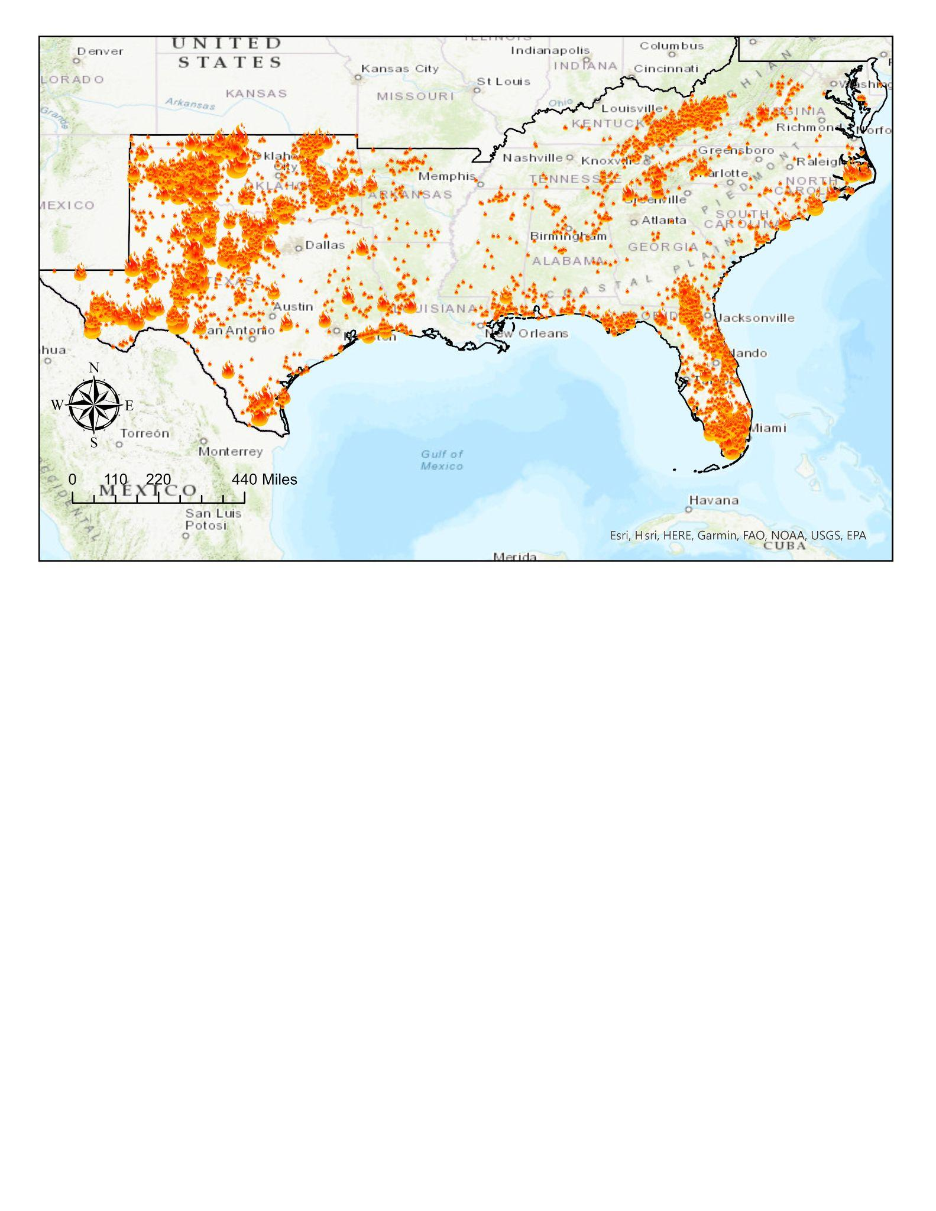
Figure 1: Wildfires (>500 ac) from 1984 to 2024. Source: Analysis data, own elaboration.

